## 

## 

## Title :- Debreberhan Teacher

## Education and vocational Training College E-Learning System

**CHAPTER ONE**

**1.0 INTRODUCTION**

The learning process needs techniques and tools to present the knowledge (from different

Resources) interact with it and share it with others. In this context, E-Learning is becoming an

Important tool to support the learning system to achieve its goal. E-Learning became hot topic in the 1990's after the spread of the Internet. Although it has a relative short history, it is becoming an important part of the learning. The majority of the colleges adopted some kinds of eLearning within its learning system.

Generally, the internet is new media, it has been spread in 1990’s, furthermore, the E-

Learning is very recent tool, and so this sector needs more and more researches.

E-learning, like many terms in Internet, does not have current definition which can be accepted by all. Some terms which are frequently interchanged with E-learning include:

* Online learning/ education
* Distance education/ learning
* Technology-based training
* Web-based learning/training
* Computer-based training/learning from a CD-ROM.

The researchers can find many definitions of E-learning much more than what they expected because E-learning is becoming very interest to many. Also we find a specific definition, "E-Learning: the use of new multimedia technologies and the Internet to improve the quality of learning by facilitating access to resources and services as well as remote exchanges and collaboration."

E-learning is not intended to replace conventional methods of training such as classroom Teaching. Its aim is to create an augmented learning environment where technology is used to deliver a combined range of teaching techniques aimed at maximizing the individual's participation in the learning process.

**TYPES OF ELEARNING APPROACHES:**

There are three types:

1. **Enhanced approach**: the e-Learning solutions used to support, facilitate and enhance the f2f (face to face) learning by using web-based technology, e.g. Course management systems. Even if this approach can reduce some academic seat time (f2f), the reduction must be no more than 24%.

2**. Blended approach**: this kind mixes traditional f2f and online learning, consequently, substantial portion of content is delivered online; typically this approach can reduce 25 to 74% of f2f meetings.

3. **Online approach**: it uses the virtual learning (VL), which can be realized without any need to f2f meeting, however, this approach could have some f2f meeting, e.g. for exams, but more than 75% of the course content is delivered online.

**1.1 Background**

Debre berhan teacher educational and vocational College is located in debre berhan city of amhara Regional state, which is 130kms north of Addis Ababa. The college started its operation in 1949 E.C. The main objective of the college is to produce teachers and educational experts capable of building up citizens by shaping the generation with knowledge, morality, ability and skills, feeling national responsibilities, enjoying positive human and democratic outlook, having developed research capacity, standing for the quality and development of education and equipped with ethical values of teaching and other related professions committed to serving the society to the best of their capacity and ability.

**1.2 Statement of the Problem**

At present Debre Berhan Teacher educational and vocational Training College has no E-learning system that is available for all courses and introduces students with the technology .The college course coordinators distribute modules to instructors, and instructors provide these modules to students based on their department type. The applicability of those modules is not more than two semester. It is compulsory to prepare such modules year by year to continue teaching-learning process on the college. In order to prepare such modules tones of papers, high human power and other module preparation equipment are also needed. This module distribution system leads the debre berhan teacher educational and vocational training college to great crisis of economy. The students also waste time, money and effort in always going back to their instructor to submit assignments and to view the result of course including quizzes, tests and assignments. Also most of the college students have no computer skill that is expected from the college students**. Overburden of work on the employee of the college is also another problem during preparing, duplicating and distributing modules.** Therefore, we will need to improve existing system by eliminating the above problems to increase satisfaction of teaching-learning system.

**1.3 Project Initiation**

* Coming and going of students so many times for purpose of receiving and submitting assignment
* Preparation of modules per year
* Wastage of colleges resource
* Lack of course material on students
* Tedious process of grade showing process.
* Work overload on the employee.
* Requiring of today’s ICT technology.

**1.4 Objectives of the project**

**1.4.1 General objectives**

The general objective of this project is to design and to develop an E-learning System for Debre Berhan Teacher Training College.

**1.4.2 Specific objectives**

The specific objective of this project is:

* Studying about problem of the existing system of the college
* Gathering required information for proposed system
* Analyzing the gathered information
* Compare and contrast the proposed system with existing system
* Considering applicability of proposed system for the college.
* Designing the proposed system
* Implementing the system
* Testing system

## 1.5 Scope of the project

In **Debre** Berhan Teacher Educational and Vocational Training College the following sub systems are required to be automated.

* Providing tutorial online
* Online examination
* Online video learning
* Online grading
* Distributing module via the internet
* Distributing assignments for students

**Because of taking the time and budget allotted to this project in to account only selected activities are going to be automated and implemented in this proposed system. Specifically the activities that are supposed to be automated are:**

* Provide course materials online that students can access it everywhere, at all time.
* Providing online Assignment for students.
* Show course grades for students online without going to their instructors.
* Students submit their assignment online
* providing online tutorial

**1.6 Limitation of the project**

**Due to the shortage of time and other mini projects the following activities will not include to be automated in the existing system. It is better to inform others who are interested to do on this project.**

* It doesn’t generate CGPA of students.
* It doesn’t give online examination.
* Online evaluation of students is not included in the system.
* Online registration

### 1.7 Risk Assessment & Management

**The project can’t be completed as it is initially planned. This is due to the fact that a problem may happen in the process of project development. We assumed the following risks can be encountered:**

* **The unavailability of data source (information gathering) on time may extend the project completion time. We will manage this problem by searching information from college**
* **Damaging the computers that we work on, it will be managed by using backup.**
* **Unavailability of internet also another problem we will use other reference materials**
* **Shortage of Time. We managed such problem by using additional time from our rest time.**
* **Virus can attack our project. We used updated antivirus to manage this problem. Power fluctuation problem. It is using laptop that have high power pack ups are used.**

### 

### 1.8 Method of data collection

The data collection process to conduct this project includes both the qualitative and quantitative data. This will be done through the use of instruments such as observations, interviewing and the Internet. From these three data gathering tools, interview will be used to collect data from the office of the registrar and from the instructors. Observation will also be used to oversee the required things in the college.

### 1.8.1 Interview

Interview is a conversation or questioning, for the purpose of eliciting information for publication, the published statement so elicited.

**Interview Procedures**

* First we will decide to interview to the registrar manager.
* We will schedule the interview and confirm the meeting time and date a day before conducting the Interview.
* We will critically look as much as possible about the topic of interview before conducting the interview.
* We will prepare all materials required for the interview like note books, pencil or pen and if there is audio recorder.
* Conducting the Interview by fulfilling all criteria’s required for the interview
* Examining the interview by preparing a written summary of the key points discussed in the interview that are relevant to our topic.
* Finally, we will determine its usefulness by analyzing whether the information obtained from the interviewee is useful, contribute, correct for the development of our topics.

### 1.8.2 Observation

Observation is the other instrument that will use to collect data which will be necessary for our web-based system project for the college. In this process we will try to investigate the information by making our selves participates in the process. And observations will also helping us to relate the information obtained from the interviewee by looking to the reality of the college.

### 1.9 Development Tools

Developing DBTEVTC E-learning system needs a number of tools that makes the process easy and fast. These development tools are hardware tools and software tools both collaboratively work to achieve specific goals. Hardware tools are all tools that we touch and feel and help to work with the project. Software tools are programs or instructions that help us to simplify work. Here are some development tools:-

**Hardware tools**

* Personal computer(Pc)
* Digital camera
* Pen and paper
* Hard disk with minimum of 512GB
* RAM with minimum of 2GB
* Processor with Pentium IV
* Flash

**Software tools**

* Web browser (Mozilla Firefox, Google chrome, opera): So we can check the system across a variety of platforms.
* Operating system of window7 to develop the system
* Adobe Photoshop: for editing images and icons for the interface of the system.
* XAMP server
* Widow notepad
* Microsoft office word and power point
* Rational Rose for UML diagram

## 1.10 Schedule of the project

This project is expected to be completed in two semesters of 2014/2015 gc academic year. Some parts of the project component to be completed in the first semester are up to design and the rest of activities such as implementation, testing and maintenance would complete in the next semester including other minor activities.

**Review**: In this phase we formally examine the project and provide concept notes based on the review. **Concept Notes:** In this phase we provide whole concepts about the project and achieve the required idea to begin the project. Generally, the schedule of the project is provided for the purpose of doing the tasks on time. So we represent the schedule of the project using Gantt chart as follows.

**Gant Chart**

|  |  |  |
| --- | --- | --- |
| No. | Task Name | ***2007 EC.*** |
| ***Nov8,2007- Dec26,2007- Jan 16,2007- May 25,2014- Jun7,2007-***  ***Dec25, 2007 jan15,2007 Feb18,2007 Jun5,2007 Jun9,2007*** |
| 1 | Requirement gathering |  |
| 2 | System requirement specification |  |
| 3 | System designing |  |
| 4 | System implementation |  |
| 5 | Operation testing |  |

# Cost estimation

For the successful accomplishment of the project, the costs associated with each items required have been estimated. This will help us to limit the constraints related to cost while the project is conducted. From the beginning up to the end of this project we planned the following cost list.

|  |  |  |  |  |
| --- | --- | --- | --- | --- |
| No. | Item | quantity | Price per item | Total price |
| 1 | Paper | 300 | 25cent | 75 |
| 2 | CD | 3 | 10 birr | 30 |
| 3 | Pen | 5 | 5 birr | 25 |
| 4 | Mobile card | 4 | 25 birr | 100 |
| 5 | Print | 150 | 1 birr | 150 |
| 6 | Binding | 2 | 10 birr | 20 |
| 7 | Miscellaneous cost | - | - | 400 |
| 8 | transport |  | 2.5 | 50 |
| Total | 8 | 464 |  | 850 |

**1.11 Feasibility analysis**

**Feasibility is a measure of how beneficial and practical the development of an information system will be. Given enough time, money, and personnel, almost all system projects are feasible. Feasibility studies provide the information that allows management to:**

* **Pick one of several possible alternative systems that meet the requirements.**
* **Decide if a system project should proceed to the next phase.**
* **Choose between several systems projects that must compete for the same set of limited resources.**

**Economic feasibility**

Economic feasibility is a measure of how cost effective the proposed solution will be. It is possible to develop the proposed system in minimum cost and also can be hosted in lower price. The E-learning system can be used after completion free of cost.

**Operational feasibility**

**Operational feasibility is a measure of how well the solution will work in the organization. Operational feasibility is dependent up on the human resources available for the system. This web based system for E-learning in** Debre Berhan teacher educational and vocational training college **will attain its desired objectives. It can solve the problems in distributing module (course material) and assignment; therefore it will minimize the amount of effort to do all through manually. And it will perform the basic content management functionality.**

**Technical Feasibility**

**Technological feasibility measures the practicality of a specific technical solution to the problem. It is also a measure of the availability of technical resources and expertise. Technical feasibility is assessing the organization‘s ability to construct the system. Since This online system for educational purpose need technical resources to implement, like computer with network. We expect that, the system can be operated in simple way and all users can access easily by giving some training for them.**

**1.12 Team organization**

**The project team member is structured with 5 members, one group leader, one vise leader, one secretary, and 2 other members’ Problem solving takes place in group. Decision making on problem solving process are made by group member’s agreement, which is much better than individual decision making.**

|  |  |  |  |  |
| --- | --- | --- | --- | --- |
| **Debre Berhan Teacher Educational And Vocational Training College E-Learning System** | | | | |
| **S.No** | **Name** | **ID NO.** | **Email Address** | **Responsibilities** |
| 1. | **David Amanuel** | COMPR/011/04 | - | **-** Data gathering  -Designer |
| 2. | **Mujib Fujaga** | COMPR/032/04 | Mujibf032@gmail.com | -Group coordinator  -Documentation  -Implementation |
| 3. | **Rahel kiros** | COMPR/036/04 | - | -Secretary  -Designer |
| 4. | **Samrawit Yimer** | COMPR/040/04 | - | - Data gathering  -Designer |
| 5. | **Werku Shewafera** | COMPR/049/04 | Werkushewafera2112@gmail.com | V/group Coordinator  -Testing |

**Chapter Two**

**System Analysis**

**2.1** Introduction

**The existing system of Debre Berhan Teacher Educational and Vocational Training College is manually operated. Different activities are performed as follows:**

**Distributing modules, allocating assignments and showing course results are performed by instructor and registration process is performed by registrar office. The overall teaching –learning process is controlled by academic dean.**

**The current system that we have observed is faced a lot of problems, due to this reason we analyze those problems to provide some alternative solutions.**

### 2.2 Problems of the existing system

**As we have observed in the data collecting phase, the main problems in Debre Berhan Teacher Educational and Vocational Training College are wastage of resources during preparing, duplicating and distributing process of modules.**

**Overburden of work on the college’s employee is also seen on the current system of Debre Berhan Teacher Educational and Vocational Training College during duplicating and distributing modules, since each course has its own module to be distributed per student.**

Students also submit their assignment to their instructor in hardcopy, and they view result of the course such as quizzes, tests and assignments by going back to their instructor. Such process leads students to waste their time, effort, money and make them unsatisfied.

**Generally those problems can be defined as:**

* **Wastage of college’s resource**
* **Time consuming because of it is manually operated**
* **Lack of consistency of data**
* **Work overload on college’s employee**
* **Lack of students satisfaction**

### 

### 2.3 Role players in the existing system

### ****Student****

* **Applying to be registered**
* **Collecting modules or reading materials from instructor**
* **Collecting assignments from the instructor**
* **Take lecture by coming to class**
* **Submit assignments**
* **View grade from registrar office**
* **Receive diploma certificate from registrar**

**Instructor**

* **Distribute modules**
* **Give examination**
* **Receive assignments**
* **Give lecture on class**
* **Show course results including assignment, quizzes and examination results.**

## ****Office of registrar****

* **Checking the student’s previous information.**
* **Registering student.**
* **Preparing and giving student’s grade report.**
* **Process withdrawal and give withdrawal form.**
* **Preparing and giving diploma certificate for students.**

**Academic dean**

* **Control teaching-learning process**
* **Prepare class schedule**
* **Assign instructors**

**2.4 Workflow of the existing system**

DBTEVT College

Instructors receive students list from registrar office, give lecture, provide modules, give assignments and show course result

Students take identity card after registration, attend class and receive every input of instructor

Registrar office fixes registration date, Checks overall student’s information and register students

Academic dean controls overall teaching-learning process and assign instructor for courses. Also prepare schedules

**Fig 2.1 Work flow of the existing system**

**2.5 Business Rules**

This part specifies and gives understanding of activities which are being done in the existing system in terms of business rule.

**BR1: The student must pass the exam prepared by amhara region educational bureau.**

**BR2: Students who want to join Debre Berhan teacher education and vocational training college must have full of documents and qualification of Ministry of education certificates.**

**BR3:If student is above first year first semester he/she must score promotion grade for registration**

**BR4: The registrar Determines registration date and clarify required criteria.**

**BR5: Student should be registered on the specified registration date.**

**BR6: Each student should have unique identification card to be identified.**

**BR7: Choice for field of study is based on the student’s interest.**

**BR8: The academic dean is the one who is responsible to control the overall teaching learning process.**

**2.6 Proposed System**

**The proposed system that we analyze can solve some portion of the existing system. When we see the solution, making the college computerized system, it will solve most of the problems in the teaching-learning process. This project has much significance**

* **Reduce the extravagancy of the college’s resource.**
* **Reduce the time and task required to perform the operation within the college.**
* **It will provide speed, efficient, Flexibility and reliability system.**
* **For students, better satisfaction of the speed provided by the instructor in module (course material) distributing, seeing course result and submitting assignment.**
* **And it improves the moral (motivation) of the users.**

**2.6.1 Functional Requirement**

DBTEVTC E-Learning system has the following functionalities:

* **Module uploading:** Enables the instructors to login to the system and upload modules and other references.
* **Downloading:** Enables the students to login to the system and download modules.
* **Viewing course result:** Enables the students to login to the system and view their course results including quizzes, tests and assignments.
* **Registration :**enables registrar office to register student who fulfill required criteria
* **Posting course result:** Enables the instructors to login to the system and post course result for students.
* **Take assignments:** Enables the student to take assignments online.
* **Manage accounts:** Enables administrator to update/delete accounts.
* **Authentication:** The system will be verified by denying unauthorized user from using the system.

### 2.6.2 Non- Functional Requirement

DBTEVTC **E**-Learning system has the following Non-Functional Requirements to achieve its functionality.

* **NFR1: Usability:-**The system is easy to learn and operate. The User interface for this system will be simple and clear. The E-Learning services are easy to gain and use i.e. the service doesn’t require special training.
* **NFR2: Availability:** – This system is available in everywhere (where internet/intranet service reach) and at all time for those who have access to use the system.
* **NFR3: Performance**-The system will have good performance i.e. fast response time and optimal workload.
* **NFR4: Security:** – The system will be secured as much as possible so that there is permissible information flow regarding to that can do what.

So it is designed to be very secure by providing a login feature which authenticates the user by means of a user name and password with which user will be able to login to his/her respective pages and use the system as required.

* **NFR5: Portability:**-The system is machine independent and software system independent so it can be moved to different target platforms.
* **NFR6: Reliability: –** The system is effective and consistent in that integrity of information is maintained and supplied to the system.
* **NFR7: Documentation: –**The system contains the required documents needed to implement the project.

**2.7 Activities of the proposed system**

**Registration process**

**To join Debre Berhan teacher educational and vocational training college the registration process is performed by registrar office. The registration process is performed as every students or applicant who want to join Debre Berhan teacher educational and vocational training college and fulfills the entire requirement can get registration after approved all supportive documents and photos. After the registrar officers complete the registration process they submit the report about those registered students to instructor.**

**Upload modules and assignments**

**Students those who have been registered for the course can download all modules from internet/intranet that is uploaded by instructors. Assignment questions are uploaded for student who registered for given course.**

**Submission of assignments**

**Every student is expected to submit his/her assignments via internet/intranet; the student should have to write his/her full name, ID number, course name, department name ,academic year, semester in the form. The system verifies the information provided by the student and then submits by clicking the submit button.**

**Viewing of course result**

Every student is expected to view his course results including quizzes, test, final examination and assignment result online. The student should have to write his/her full name, id number, course name, department name, academic year and semester in the form. **The system verifies the information provided by the student and then show by clicking the view button.**

**2.8 Dynamic Models**

**2.8.1 Use case model**

**To model a system the most important aspect is to capture the dynamic behavior. To clarify in details, dynamic behavior means the behavior of the system when it is running or operating. So only static behavior is not sufficient to model a system rather dynamic behavior is more important than static behavior. In UML there are five diagrams available to model dynamic nature and use case diagram is one of them. Now as we have to discuss that the use case diagram is dynamic in nature there should be some internal or external factors for making the interaction.**

**These internal and external agents are known as actors. So use-case diagrams are consists of actors, use cases and their relationships. The diagram is used to model the system or subsystem of an application. A single use case diagram captures a particular functionality of a system. So to model the system we used the following use case diagrams.**

**2.8.1.1 Actor identification**

**The purpose of actor analysis is to identify all of the actors that interact with the system. An actor has a role in that interacting with the system.**

**The actors that interact with the system are:-**

* **Administrator**
* **Student**
* **instructor**
* **registrar office**

**2.8.1.2 Use-case identification**

**Identifying the activities that are mainly performed on the proposed system is the basic thing in analyzing a new system. The following use cases have been identified from the system specification.**

* **Upload module**
* **Download module**
* **Upload assignment**
* **Download assignment**
* **Post course result**
* **View course result**
* **Manage user account**
* **Login**
* **register student**

**Use case diagrams graphically describe system behavior (use cases). These diagrams present a high level view of how the system is used as viewed from an outsider’s (actor’s) perspective. From the identified use cases and actors the use case diagram of the system is shown in Fig3.1**

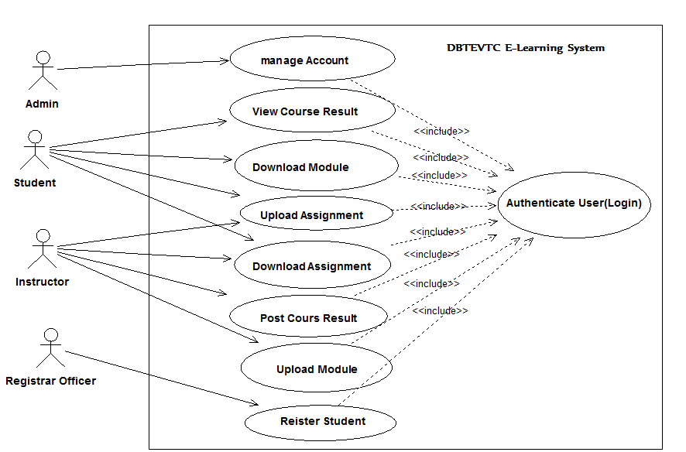

Fig Use case diagram for E-learning system

**Use-case scenario for upload module**

|  |  |
| --- | --- |
| **Use-case name** | **Upload module** |
| **Identifier** | **Uc1** |
| **Description** | **The process will start by activated the system or the window and then home page and the login link also displays.** |
| **Actor** | **instructor** |
| **Pre-condition** | 1. **An instructor should have to enter a valid user name and password.** 2. **The system should verify the input user name and password.** |
| **Post-condition** | 1. **Upload module successfully.** 2. **Finally logout from page** |
| **Basic course of actions** | **Step 1: The** instructor **should clicks on upload module link.**  **Step 2: instructor should have to click on browse the file button**  **Step 3: browses where the file to be uploaded**  **Step 4: Then** instructor **click on upload button.** |
| **Alternative course of action** | **Step 4: If the size or type of file to be uploaded is out of size, the** instructor **should compress the file.** |

***Table 3.1*** Description of upload module use case.

**Use-case scenario for download module**

|  |  |
| --- | --- |
| **Use-case name** | **download module** |
| **Identifier** | **Uc2** |
| **Description** | **The process will start the student by activated the system or the window and the home page and login link will be displayed.** |
| **Actor** | **Student** |
| **Pre-condition** | 1. **Student must insert his/her ID number as user name and password.** 2. **The system should to verify whether it is valid or not.** |
| **Post-condition** | 1. **Download module successfully** 2. **Finally logout from the page** |
| **Basic course of actions** | **Step 1: the student should click on download module link.**  **Step 2: he/she enter course code and department name**  **Step 3: student click on show file button.**  **Step 4: The student should have to click on the download link.** |
| **Alternative action** | **Step 3: if no uploaded file it shows No file message** |

***Table 3.2*** Description of download module use case.

|  |  |
| --- | --- |
| **Use-case name** | **Upload assignment** |
| **Identifier** | **Uc3** |
| **Description** | 1. **This process can be performed by instructor as well as by student. An instructor uploads assignment questions for student.** 2. **Student downloads the assignment questions and after completion the student should submit the answers to instructor.** |
| **Actor 1** | **instructor** |
| **Actor2** | **Student** |
| **Pre-condition** | **1: An instructor/student should have to enter a valid user name and password to upload assignments.**  **2: The system should validate the user by checking user name and password.** |
| **Post-condition** | 1. **The assignment was uploaded successfully.** 2. **Finally logout from the page** |
| **Basic course of actions** | **Step 1: the user click on upload assignment link**  **Step 2: user enters course code and department name**  **Step 3: then he/she press on upload button**  **Step 4: The system should have to check the submission date.** |
| **Alternative course of action** | **Step 4: if submission date has been passed the student cannot upload the assignment so, student must submit on the provided date.** |

**Use-case scenario for upload assignment**

***Table 3.3*** Description of upload assignment use case.

**Use-case scenario for download assignment**

|  |  |
| --- | --- |
| **Use-case name** | **Download assignment** |
| **Identifier** | **Uc4** |
| **Description** | **This process can be performed by instructor as well as by student.**   1. **An instructor can download assignment answers submitted by student.** 2. **Student can download assignment questions that uploaded by instructor.** |
| **Actor 1** | **instructor** |
| **Actor2** | **Student** |
| **Pre-condition** | 1. **An instructor /student should have to enter a valid user name and password to download the assignment.** 2. **The system should validate the user by checking user name and password.** |
| **Post-condition** | 1. **The assignment was downloaded successfully.** 2. **Finally logout from the page** |
| **Basic course of actions** | **Step 1: the user click on download assignment link**  **Step 2: he/she enters course code and department name**  **Step 3: then he/she press on download button**  **Step 4: the user should have to click on download link** |
| **Alternative course of action** | **Step 3. If no uploaded assignment no file message will be displayed** |

***Table 3.4*** Description of download assignment use case.

|  |  |
| --- | --- |
| **Use case name** | **Manage user account** |
| **Identifier** | **Uc5** |
| **Description** | 1. **An administrator manages users’ account.** 2. **Updates user account like changing user name and password.** 3. **Administrator creates new account for instructors.** |
| **Actor** | **Administrator** |
| **Pre-condition** | 1. **An administrator should have to enter a valid user name and password in order to create, update and delete user account.** |
| **Post-condition** | 1. **You update, create and delete user account successfully message will be displayed.** 2. **Finally logout the from the page.** |
| **Basic course of actions** | **Step 1. Administrator should have to choose account item**  **Step 2. Then click on the selected account item.**  **Step 3. The administrator should have to create/delete/modify the user’s account.** |
| **Alternative course of action** | **Step 3. Confirmation/rejection message will be displayed.** |

**Use-case scenario for manage user account**

***Table 3.5*** Description of manage user account use case.

|  |  |
| --- | --- |
| **Use case name** | **Register student** |
| **Identifier** | **Uc6** |
| **Description** | **1. Registrar officer registers students who fulfill necessary criteria** |
| **Actor** | **Registrar officer** |
| **Pre-condition** | **1. Registrar officer enter valid user name and pass word to get student registration form.**  **2. The student must pass the exam prepared by amhara region educational bureau if he/she is fresh.BR1**  **3. If student is above first year first semester he/she must score promotion grade for registration. BR3** |
| **Post-condition** | 1. Instructor can access the registered student list 2. **Finally logout from the page** |
| **Basic course of actions** | **Step 1**.The registrar officer fills the basic information of the student.  **Step 2**. After completion of filling the form he/she click on register button.  **Step 3.** If ID repetition occurs the error message will be displayed |
| **Alternative course of action** | **Step 2. If the same id is present on the same academic year the system displays this student already registered message. So the registrar officer must give unique ID for each student on the same academic year.** |

**Use case scenario for registering student**

***Table 3.6*** Description of register student use case.

|  |  |
| --- | --- |
| **Use case name** | **Post course result** |
| **Identifier** | **Uc7** |
| **Description** | The course instructor posts the result of the course including quizzes, tests and assignments for students |
| **Actor** | **Instructor** |
| **Pre-condition** | 1. Student must submit the assignment and take all class exams. 2. An instructor should have to enter a valid user name and password in order to post course result. |
| **Post-condition** | 1. Post Success message will be displayed 2. . Finally logout from the page. |
| **Basic course of actions** | **Step 1:** instructor clicks on post student result link.  **Step 2:** Then he/she fill every result of the course including assignment, quizzes and final examination.  **Step 3:** then he/she click on post button. |
| **Alternative course of action** | **Step 2:** if instructor fills incorrect result such as filling the result out of bound he must check the result. |

**Use-case scenario for post course result**

***Table 3.7*** Description of post course result use case.

|  |  |
| --- | --- |
| **Use case name** | **View course result** |
| **Identifier** | **Uc8** |
| **Description** | The students can view the result of the course including quizzes, tests and assignments posted by the instructor. |
| **Actor** | **Student** |
| **Pre-condition** | 1. Student must submit the assignment and take all class exams. 2. An instructor should have to enter a valid user name and password in order to post course result. |
| **Post-condition** | 1. The result of the course will be displayed successfully 2. . Finally logout from the page. |
| **Basic course of actions** | **Step 1:** student clicks on view course result link.  **Step 2:** Then he/she fills course code and department name.  **Step 3:** then he/she click on view button. |
| **Alternative course of action** | **Step 2:** ifthe student fills incorrect course code or department name he must check it. |

**Use-case scenario for view course result**

***Table 3.8*** Description of view course result use case.

**2.8.2 Activity diagrams**

Activity diagram is another important diagram in UML to describe dynamic aspects of the system. Activity diagram is basically a flow chart to represent the flow form one activity to another activity. The activity can be described as an operation of the system. So the control flow is drawn from one operation to another. This flow can be sequential, branched or concurrent. The following activity diagrams are specified in the new system of DBTEVTC E-learning.

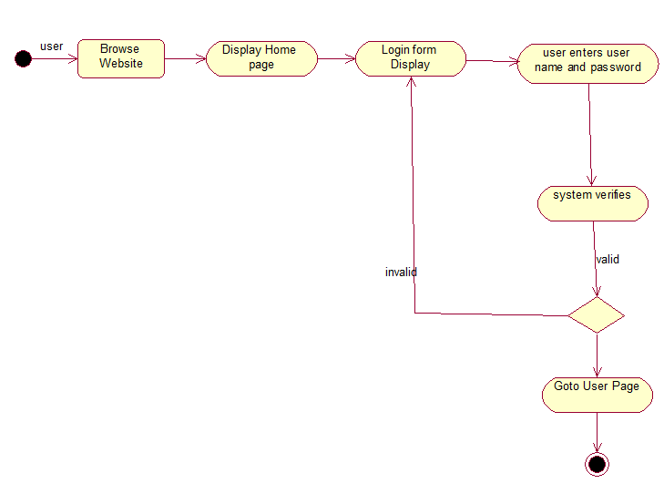

Fig Activity diagram for user login

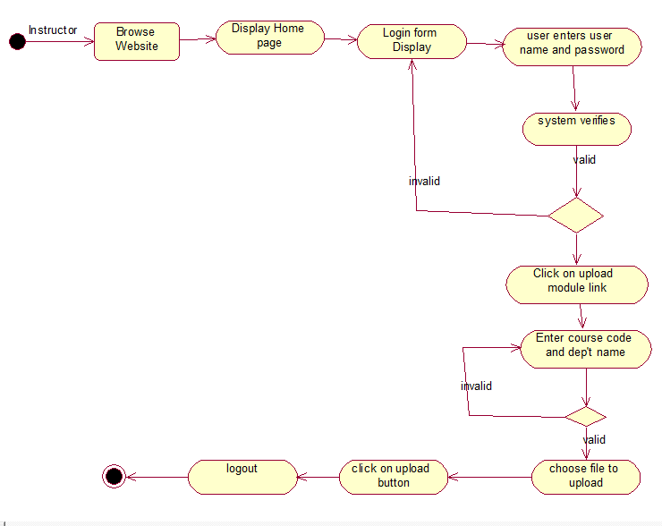

Fig Activity diagram for upload module

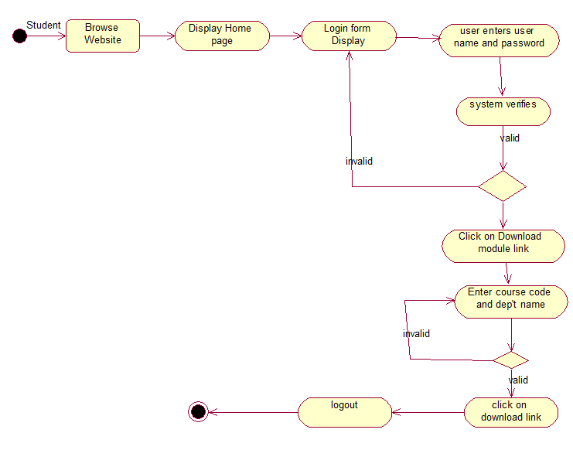

Fig Activity diagram for download module

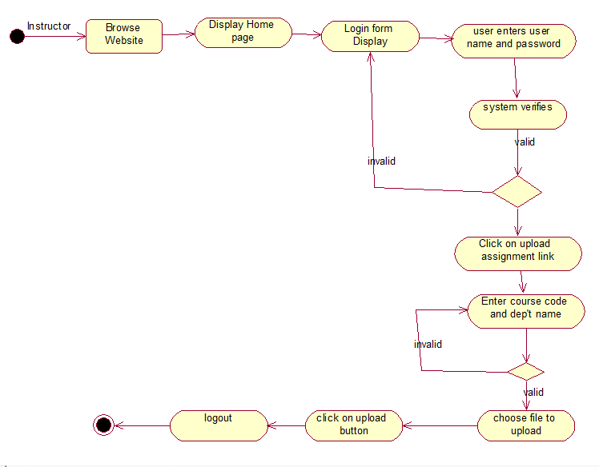

Fig Activity diagram for upload assignment

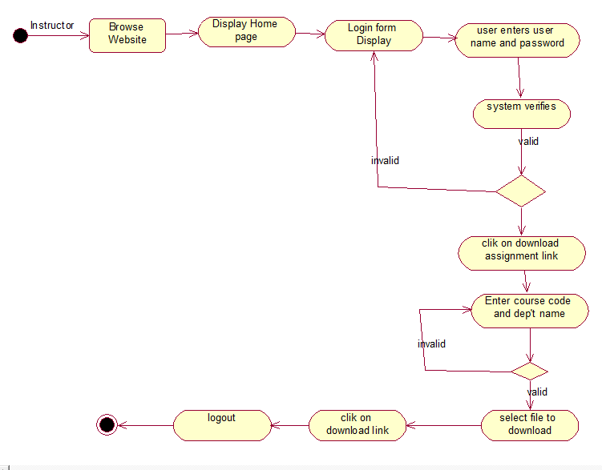

Fig Activity diagram for download assignment

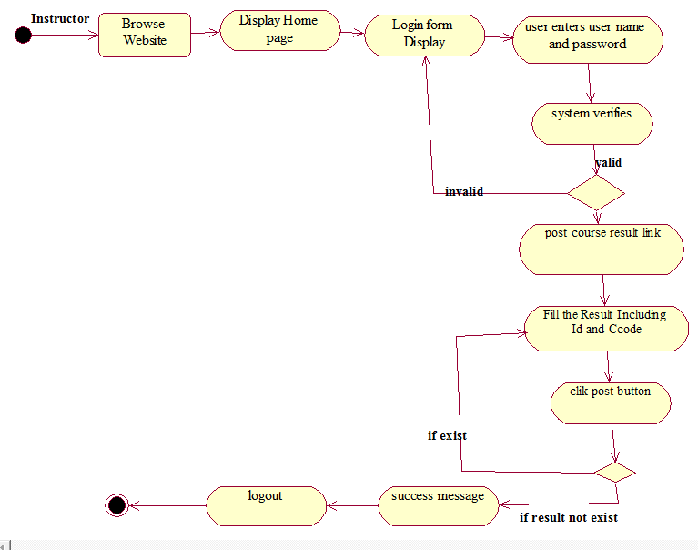

Fig Activity diagram for post course result

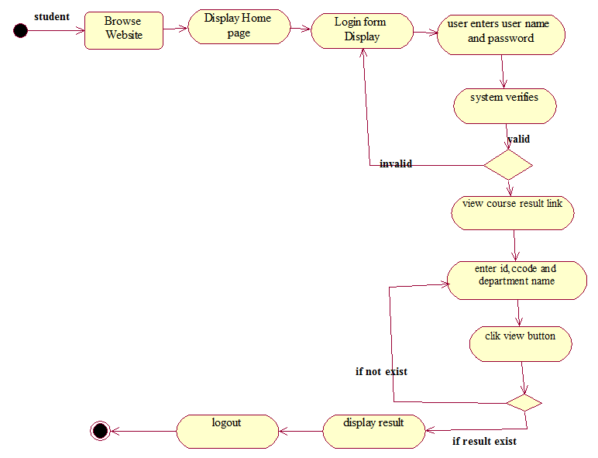

Fig Activity diagram for view course result

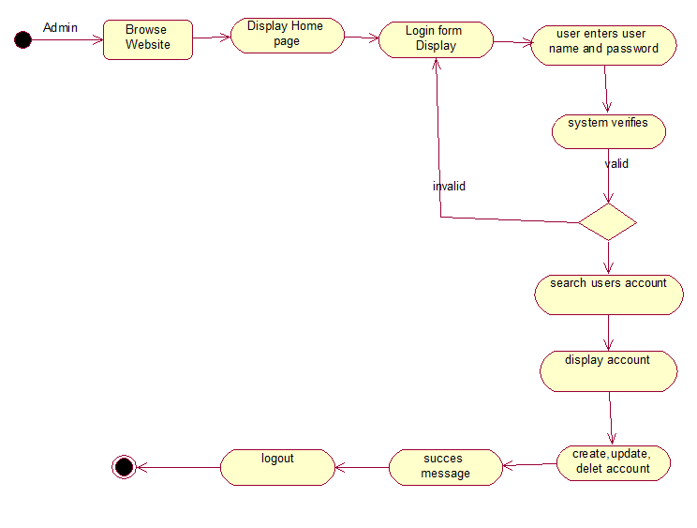

Fig Activity diagram for manage account

**2.8.3 Sequence diagram model**

A sequence diagram links use case with objects. It shows the interaction between participating objects in a given use case. It is helpful to identify the missing objects that are not identified in the analysis object model.



Fig Sequence diagram for login



Fig Sequence diagram for upload module



Fig Sequence diagram for download module

 Fig Sequence diagram for upload assignment



Fig Sequence diagram for download assignment



Fig Sequence diagram for post course result



Fig Sequence diagram for view course result



Fig Sequence diagram for student registration

**2.8.4 Collaboration Diagram**

Collaboration diagram is another form of interaction diagram. It represents the structural organization of a system and the messages sent/received. Structural organization consists of objects and links.

The purpose of collaboration diagram is similar to sequence diagram. But the specific purpose of collaboration diagram is to visualize the organization of objects and their interaction.



Fig Collaboration diagram for user login



Fig Collaboration diagram for upload module



Fig Collaboration diagram for upload assignment



Fig Collaboration diagram for download module



Fig Collaboration diagram for download assignment



Fig Collaboration diagram for post course result



Fig Collaboration diagram for view course result



Fig Collaboration diagram for student registration